Name ______________________________ HOMEWORK 6.2 Feb. 13-17
Put your initials by each night that your child practiced the following:
____Monday ____Tuesday ____Thursday
*Nightly Homework*
- Count numbers 1-75.
- Review Words to Know on the newsletter.
MONDAY-Say the picture and listen for the consonant blend in the word. Circle the consonant blend in the word.
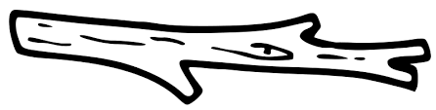  sn sl st | 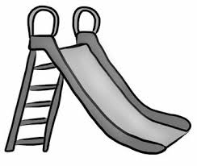  sn sl st | sl st sn | st sn sp | 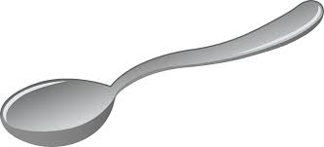  st sn sp

Make a word in the -ock family and draw a picture to go with the word.
___ock | ___ock | ___ock

TUESDAY-Read the words.

come from if stop brown
from if stop brown come
if stop brown come from
stop brown come from if

Name the picture. Say each sound in the word. Color a circle for each sound you hear.
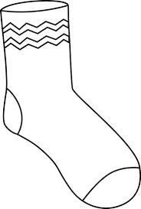

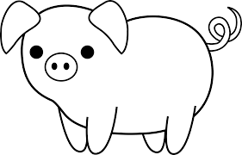

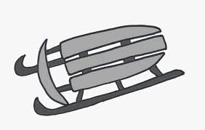

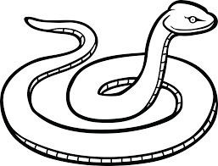

THURSDAY-Practice writing each spelling word three times.

mop | dot | log | not | hop | mom | spot

Start Right Reader 6.2 Week of February 13-17
Directions: Let your child read this to you.

Words to Know
come from
if stop
brown

Snip Stops
“Snip! Snip! Come here, Snip!” Snip nods at Meg. Snip slams to a stop. “Snip! Snip! If you come here, I can pet you.” “Snip! Snip!” begs Meg. But Snip did not step form his spot. Meg gets a step. She gets up on it. Up pops a cat! Snip did not want to step on it! Meg pets Snip. Meg hugs him, too. Snip nods.

Read these words. Find these words in the
gets but if
come stop from

sled Snip step

